[COMPANY NAME]

Flexible Schedule Policy

Updated as of [DATE]

Table of Contents

Flexible Schedule Policy 3
Flexible Schedule, Defined 3
Basic Flextime Policy 3
Suspension of Flextime Benefits and Appeals 5
Calendar Management [UPDATE SECTION BASED ON COMPANY CALENDAR TOOLS] 5
Schedule Adjustments and Company Needs 7
Collaborating with Other Employees and Clients 7
Pairing Considerations and Flexible Schedules 8
Communicating With Employees Working Flexible Hours 8
Impact on PTO Balances and Other Benefits 9

Flexible Schedule Policy

[COMPANY] wants all employees to have a healthy work-life balance, and to that end, the company permits employees flexibility in their daily work schedule if such flexibility will not harm the interests of the organization, the organization’s clients or the employee’s work team, or otherwise impair [COMPANY]business functions.

Flexible Schedule, Defined
Flexible schedules, or flextime, are variable work hours that permit employees to fulfill their workdays with flexibility in their starting and ending times.

This policy applies to all employees at [COMPANY] primary office and non-client site remote employees.

Due to client demands and location requirements, flextime may not be available for all employees, as some client-site employees may be required to adhere to a client’s standard schedule. [DELETE IF NOT APPLICABLE]

Basic Flextime Policy

Under the flextime policy, employees at [COMPANY’S] primary office (located at [ADDRESS]) and non-client site remote employees may maintain flexible work-time schedules, subject to the following rules:

- Employees at [COMPANY’s] primary office and non-client site remote employees are expected to begin work by at least [11am EST] [insert applicable time].
- Employees are expected to work [8 hours a day, for a total of 40 hours a week] [insert applicable expectations], unless an explicit exception has been made by their manager, or they are taking paid leave.
- Flextime work schedule hours for non-client site remote employees and employees at the primary office should include at least [five hours][insert applicable expectations] of availability between [11am and 5pm EST][insert applicable expectations]. [11am-5pm EST][insert applicable expectations] is considered our core hour period. However, employees only need to work at least [five][insert applicable expectations] of these core hours, and are allowed to take [an hour][insert applicable expectations] of break(s) during this core period.
- [Employees may take breaks throughout the day (such as an hour-long lunch break, many short breaks, and/ or several longer breaks over a longer work day), or employees may elect to skip taking breaks altogether, depending on their preferences to work a longer or more abbreviated work day.] [Insert applicable expectations, in line with state and federal labor laws]
- An employee’s work day should generally be completed between [7am EST and 8pm EST][insert applicable expectations], unless an exception is made by an employee’s manager.
- Employees should mark their expected work day on their calendar, and mark periods of unavailability during this time period with “OOO” (more details in the “Calendar Management” section below).
- Employees may be asked to adjust their schedule due to manager, team or company demands such as the need for in-office coverage, a requirement that every team member attend a certain weekly or daily meeting (such as stand-up), a customer emergency, the need for that person’s participation in a multi-team planning session, or an all-company retreat (described further in “Schedule Adjustments and Company Needs” section below).
- [The New York office building usually “opens” around 8:00am, so if an employee believes they may routinely be working in the office before 8:00am, they should reach out to operations staff for keys to the building front door and elevators.
- The New York office building usually “closes” around 6:00pm, at which time the building front door is locked, so if an employee believes that they may routinely be working in the office after 6:00pm, and may need to leave and return to the office after hours, they should reach out to operations staff for keys to the building front door.][Insert any other applicable constraints.]

Other work locations (remote [COMPANY] offices or client-sites) may have different operating hours and schedule expectations, but employees working remotely at home and not at a work location are generally expected to conform to the same guidelines as [ HQ city]-based employees. If an employee works at a client site or an office other than the [HQ city] [COMPANY] office, that employee should ask their manager about standard operating hours and the availability of flextime for their position or their office/ client-site location.

Suspension of Flextime Benefits and Appeals

Managers may elect to modify or suspend an employee’s flextime benefits if they believe:

- An employee is not working at [least 40 hours][insert applicable expectations] per week and/ or is not meeting their job requirements and/ or assigned work tasks; or
- An employee is not being productive during their flex-time work hours; or
- There is a change in circumstances which make it difficult for the company or the employee’s position to support a flexible schedule.

In order to suspend flextime benefits, a manager must notify the employee that their flextime benefits are being suspended and schedule a meeting with the employee to discuss any concerns and potentially set expectations for a revised employee schedule. After the conversation, a manager may either reinstate an employee’s flextime benefits with additional rules or expectations, or elect to continue suspending an employee’s flextime benefits until there is a change of circumstances.

If an employee feels that their flextime benefits has been unfairly cancelled, subjected to unfair and unmerited restrictions, or not reinstated despite a positive change in circumstances, they may request review of their manager’s decision(s) from their department head or [COMPANY’s HR team]. [If there is no HR team, insert relevant team.] If the termination, denial or continued suspension of flextime benefits does not align with Company guidelines or is otherwise problematic, appropriate actions will be taken to restore an employee’s flextime benefits.

Calendar Management [UPDATE SECTION BASED ON COMPANY CALENDAR TOOLS]

For ease of collaboration, employees should mark their expected work day on their calendar, and mark any periods of inflexible unavailability (such as appointments or other important personal matters) during this time period with “OOO.”

All employees are expected to maintain their work schedules on their personal Google Calendars, which includes a feature to set working hours:

- While viewing the calendar on a webpage, click on the gear symbol and select “Settings” on the drop-down menu that will appear.
- On the “Settings” page, go to the far right menu and click on “Working Hours.”
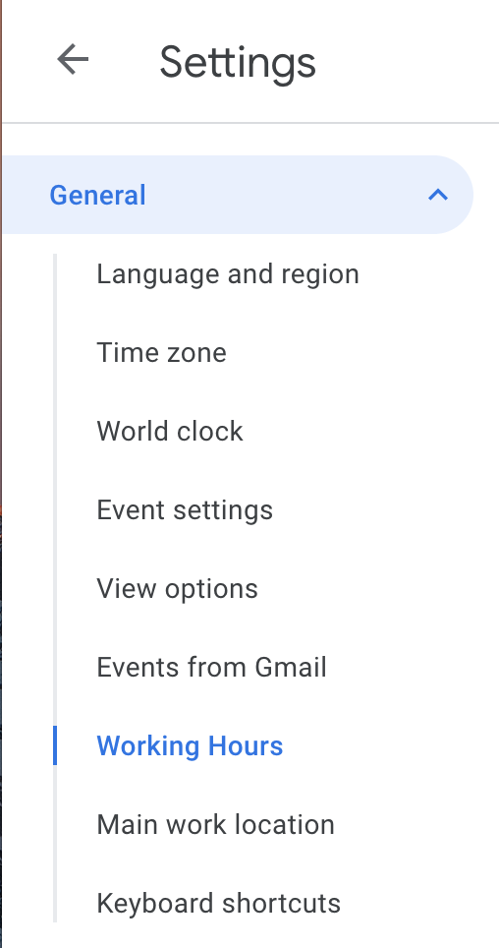
- The page will automatically jump to the “Working Hours” section. Please select the “Enable working hours” box, then select the days of the week you wish to set working hours for (typically Monday-Friday) and set your working hours for those days.
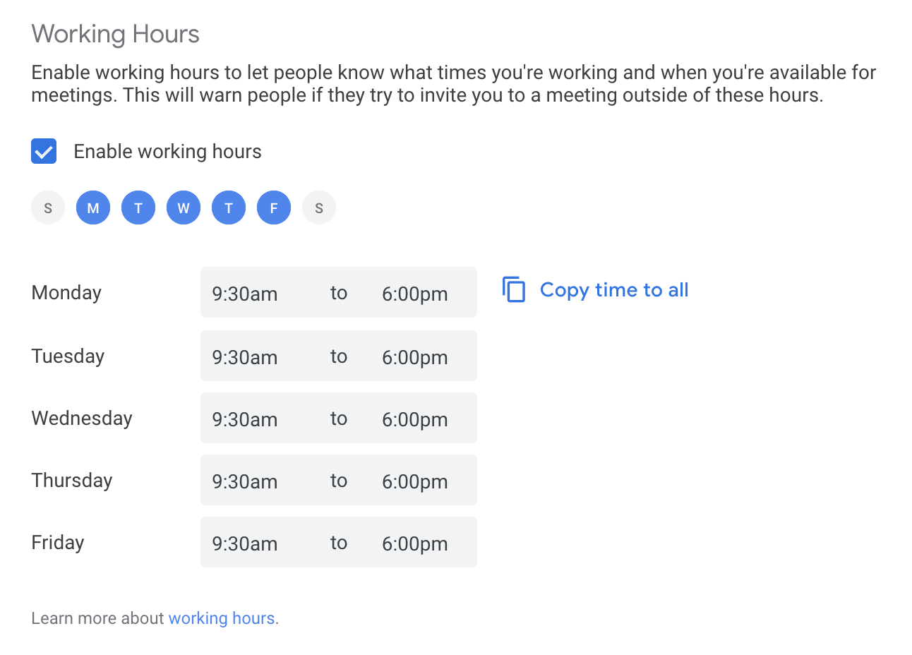

By creating an event that either begins with OOO or an “Out of Office” event for any periods any periods of inflexible unavailability, colleagues will easily be able to tell that this is a period of unchangeable unavailability and all invitations that are sent to an employee for that time period will automatically be declined.

[COMPANY] employees should communicate changes to their schedules to their manager as soon as possible. Employees should regularly also update their Google Calendars to reflect changes to their schedule, and if these changes interfere with scheduled meetings, they should communicate these changes to their teammates and any other individuals impacted by such changes.

Schedule Adjustments and Company Needs

As stated above, flextime work schedule hours for non-client site remote employees and employees at the primary office should include at least [five hours][insert applicable time] of availability between [11am and 5pm EST][insert applicable time]. (Although employees only need to work at least [five][insert applicable time] of these core hours, and are allowed to take [an hour][insert applicable time] of break(s) during this core period.) While these core hours are intended to permit sufficient time for employee collaboration, additional meetings will likely need to be scheduled outside of core hours, and employees may be asked to adjust their working schedule to participate in these meetings.
This flextime policy therefore includes an expectation that an employee may have to adjust their flexible schedule, or have adjustable start and end times, depending on meetings and other scheduling factors. However, employees still have the ability to reasonably decline a change request due to the need to attend to personal matters or existing appointments.
Some changes or limitations may be mandated by a manager, department head, or the company’s Senior Leadership team, as described in “Collaborating with Other Employees and Clients” and “Pairing Considerations and Flexible Schedules” below.

Collaborating with Other Employees and Clients
Employees who request a flexible schedule are still required to fully perform their job functions. This may require advance planning and coordination with other [COMPANY] employees as well as [COMPANY] clients. Flex hours are only permitted when the accommodations necessary to support the employee do not excessively hinder the organization’s productivity or the organization’s ability to gain new clients or support existing clients, so managers may request that an employee change their flextime schedule.

Employees on a flexible schedule must still be able to attend required [COMPANY] meetings, team meetings and client meetings, and may have to adjust their schedules to meet these requirements. Employees may be asked to adjust their schedule for company or team needs such as mandatory participation in certain recurring daily or weekly meetings, important one-time meetings, and all-company events. Employees may also be required to change their schedules due to company needs, such as the need for coverage to respond to client requests or be physically present at a specific location.

Pairing Considerations and Flexible Schedules

Employees whose work requires collaboration with other employees (often referred to as “pairing”) will ensure they create and adhere to a schedule with their paired colleague. If a flextime employee involved in pairing is not able to complete their work because their hours do not overlap with any other employee’s hours, their flextime schedule should be adjusted as necessary.

Communicating With Employees Working Flexible Hours

Communication is key to an organization supporting telework and flexible work schedules. Employees who work remotely or work a flextime schedule should receive the same information and updates as employees who work “standard hours” in an office-setting. Employees should make use of multiple communication channels (Gmail, Google Hangouts, Slack, etc.) to include remote and flextime employees in important meetings and notify remote and flextime employees of important information, and employees should therefore take care to regularly update their calendars to indicate their working hours and locations.

In the event that an employee needs an alteration to their set working hours, they are expected to notify their manager via Gmail, mark such changes in their calendar and notify any colleagues with whom they have scheduled meetings.

Impact on PTO Balances and Other Benefits

The employee’s compensation, benefits, work status and work responsibilities will not change due to participation in the flexible schedule program.

The amount of time the employee is expected to work per day or pay period should not change as a result of participation in the flexible schedule program.
Additionally, employees whose flextime schedule will necessitate the payment of overtime pay rates should raise this issue to their manager and receive explicit approval to work overtime hours, or they may not be allowed to work a full workweek.

